**Implicit Association Test**

**Introduction**

Implicit-association test (IAT) is a classic psychological task intended to measure subconscious associations between mental bias of objects in memory. It is thought to measure implicit altitude, so it can show the individual’s relative real thoughts, automatic response and avoid social-desirability bias. It especially can be useful to measure the gender, age discrimination or racism of people.

Here, I use IAT to measure the young students’ implicit altitude towards ‘old names’ - if they view old names as outgroup and if they view young names as ingroup.

**Experimental procedure**

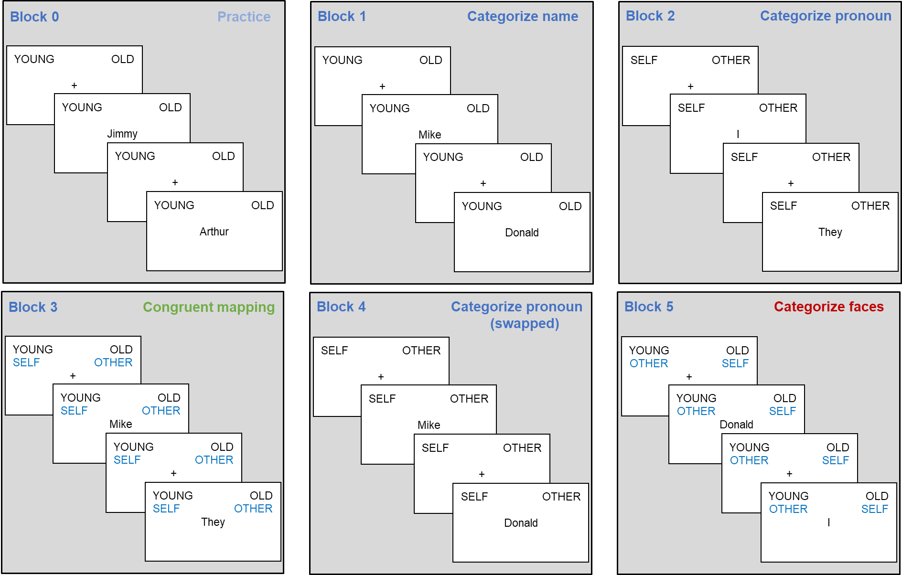

**Figure 1.** An overview of the four blocks of the implicit association task

**Task introduction in OpenSesame**

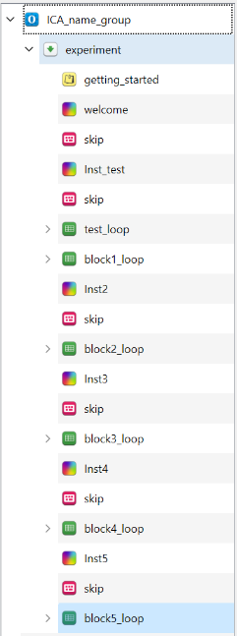**Task overview**

B.

A.

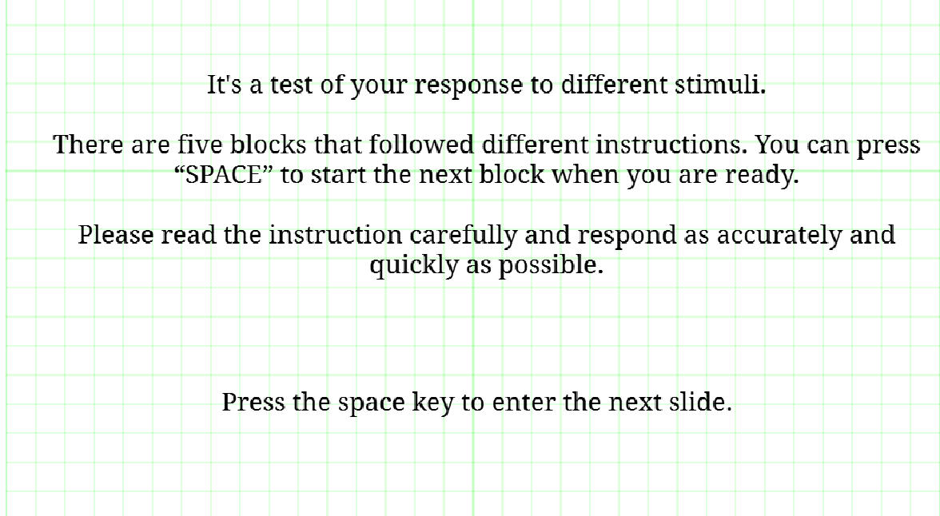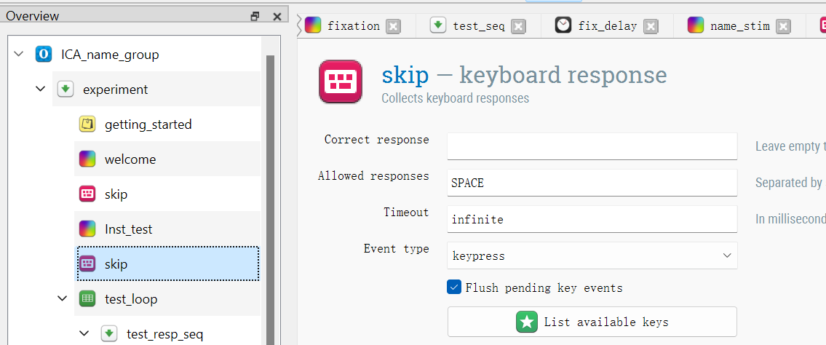

A

B

**Figure 2.** The overview area of OpenSesame and ***A.*** the welcome page and ***B.*** the skip setting.

This shows the profile of our design, I have six blocks in this experiment, including one practice group (“test_loop” in the picture) and five formal test blocks. At the beginning of the task, there is a “welcome” page (A) to show the participant a brief description of this task, and to give them more sense of control and freedom, the participants are told they can press the “space” key to skip this screen (B). Before each block, we have an instruction page to guide what they should do and emphasize what they should pay attention to. The same with the first block, they can skip the instruction and then enter the next block when they are ready by pressing the “space” key.

I use “test” and ordered numbers to name the loop and instruction page, which makes designers and the researcher in the future distinguish between blocks clearly and understand the flow of the task easier so that they could modify this conveniently on their purpose.

After we have an intuitive feeling of this task, let’s start to go through the first loop – the test block.

**Block 0 - The Test Loop**

A.

B.

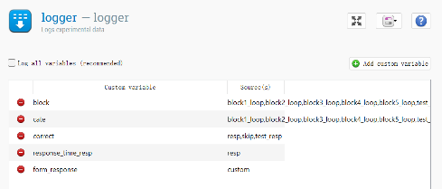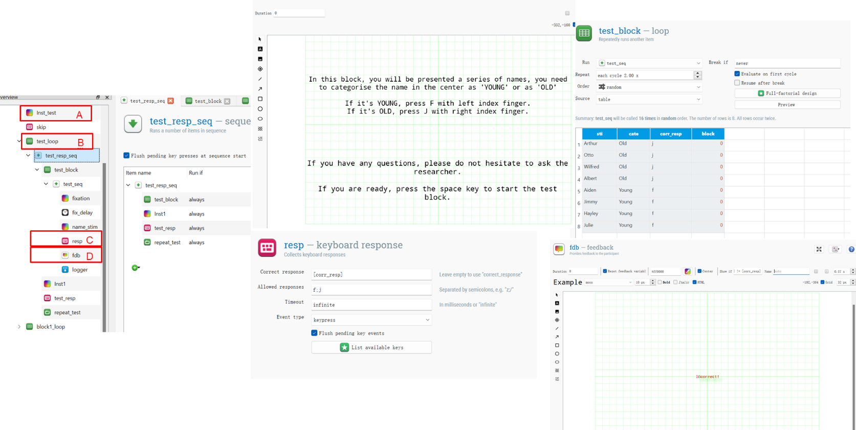

E

vi

v

iv

iii

i

ii

D.

C.

**Figure 3.** The sequence of test loop

E.

A test block is used to help participants familiarize themselves with these keys and respond to make sure they have fully understood this task.

(*A*) The “instruction” item shows participant how to respond, and remind them to ask a question if they have any questions. The duration of all the “sketchpads” is set to “0” because, after each sketchpad, I use the “response” component to manipulate the presenting time and define the response type.

(*B*) The “loop” item here stores all the stimulus and related information of them. (*i*) I choose to repeat twice by ticking “2.00x” in the “repeat” box, trying to make the practice more likely to be the same as the formal test but also do not take too much time. (*ii*) For the “order” blank, we choose “random”, because we don’t want the participant to remember the order, which might have a negative influence on their reaction time, as well as avoid the influence of specific order (e.g., the frequency and similarity of two names). In this part, (*iii*) we can see a table (because we choose the “source” as “table”, you can also invoke from an external file), every column of the table means this trial will present once, with all the related information (e.g., the name of stimuli, category, correct response, and block) can be recorded and invoked in the same trial.

(*C*) This is a keyboard response component. In this section, we can (*iv*) “set the correct response” (here, we also call it from the loop table, putting the variable name within square brackets), and (*v*) set the allowed keys in the last page (to reduce the mistype by accident).

(*D*) In the feedback page, I input two “draw text line” elements, one is “correct”, another is “incorrect”. If we want this feedback correctly, we need to specify its parameter of the (*vi*) “show if” box. For the “Correct!” feedback, we set “show if [response_resp] == [corr_resp]”, which means when participant’s response to the stimuli is the same with the the matched value (in the same column) of the “corr_resp” variable (which we could see in the table of “loop”). I also set the color of this feedback to “green” and “read” respectively to make it more significant for participant.

(*E*) Finally, I attach a “logger” in the end of the block, to log all the collected response and related information. In the logger part, I set custom variable, to make my results clearer and easy to follow.

**IAT task: Block 1 ~ Block 5**

For Block 1 to Block 5, they are all similar with Block 0 (the test loop) with (1) fixation (sketchpad); (2) fix_delay (advanced delay); (3) xxx_stim (sketchpad); (4) response (keyboard response); (5) fdb (feedback); (6) logger (logger). For these blocks, the components 1,2,4,5 are linked, sharing the same parameter. However, they are under different loops, so the values they invoke are different that they can achieve different functions and aims.

For the stimulation sketchpad (component 3, Figure 4), because the lead words are in the left/right upper, and it changes only across the block, I make a new sketchpad and put them in the right places.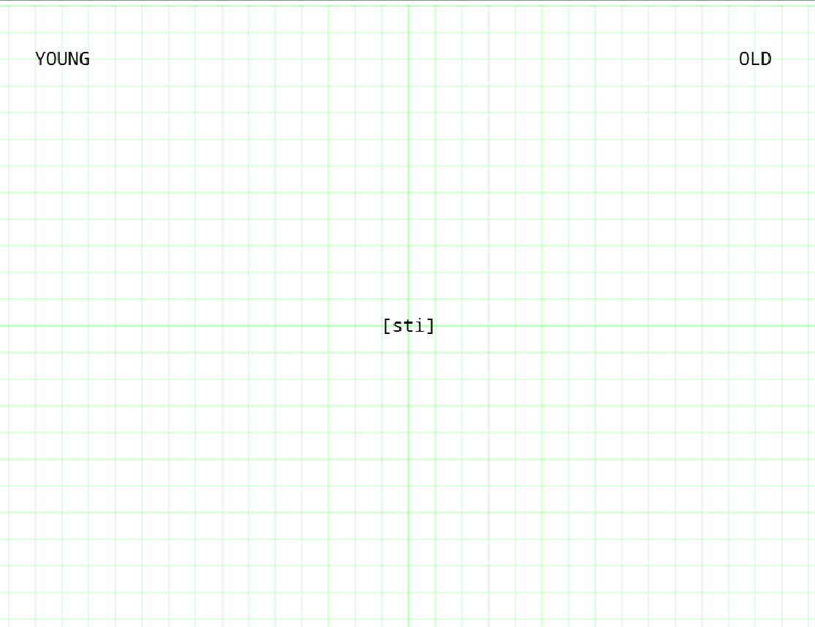 I use “[]” (square brackets) again to load the variables in the loop table just like I mentioned above.

In the mix block (block 3/5), I also set the stimulation’s “color” to [color], to present the corresponding color to the instruction.

Besides, with the combination of fixation and fix_delay, 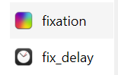(see in Figure 2), the duration of fixation is set to be “radom” 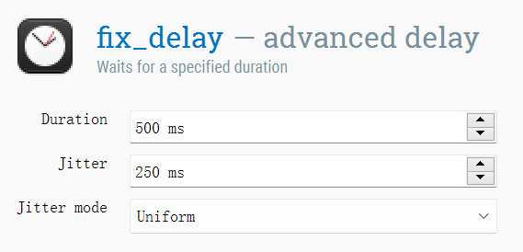, with the mean of 500 ms and the jitter of 250 ms in uniform distribution.

**Figure 4.** The stimulation sketchpad in OpenSesame

**Highlights (Innovation)**

Above all are the basic part of the IAT, besides, I also use some practical functions to make my task more completed. For example, This is widely used in psychological tasks that measure reaction time, because if we use a fixed duration of fixation, there would be a habitual response and expectation effect, which might negatively affect the behavioural results and it’s likely to fail to get the effect we want (it could also be quite useful to reduce a simple-visual-stimulation-induced potential if you are going to record EEG data simultaneously). Also, I put a repeat cycle 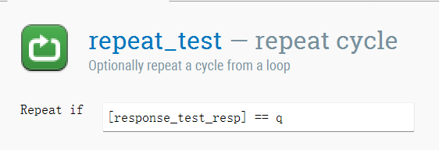 in the end of the test (also see in Figure 2) and a instruction 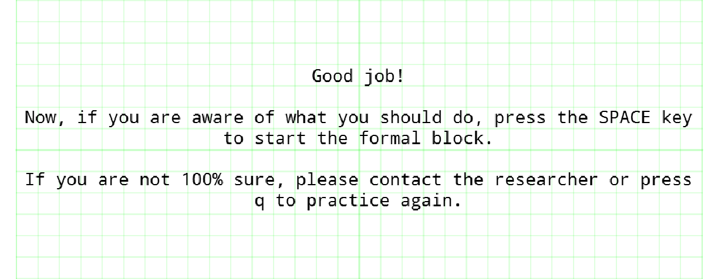 in test loop, which allows participants to press “q” to practice again if they want to familiarize the keyboards and the task again before the formal test. Last but not least, remember, If we want to use this task in a real experiment, we need to make a second version, (which the order of blocks should chang – in accordance to the order of block 4 and 5, then 2 and 3).

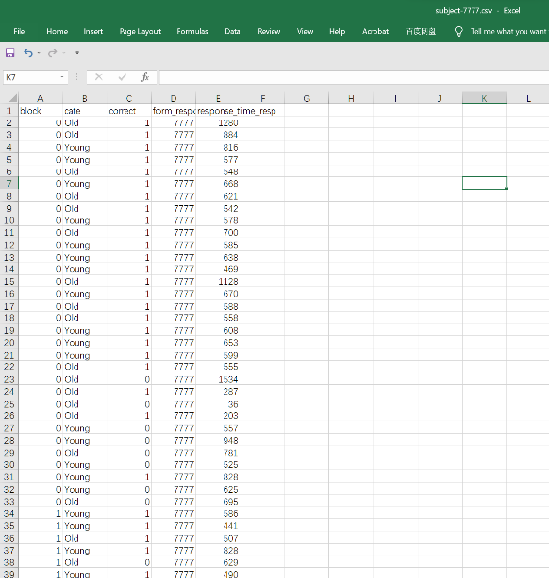**Results**

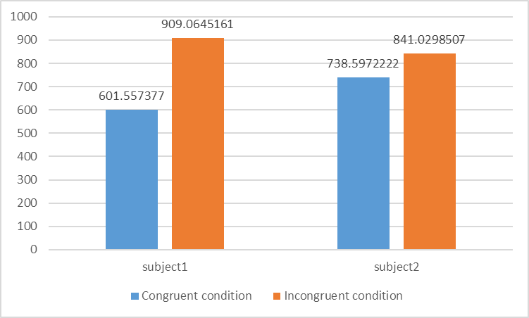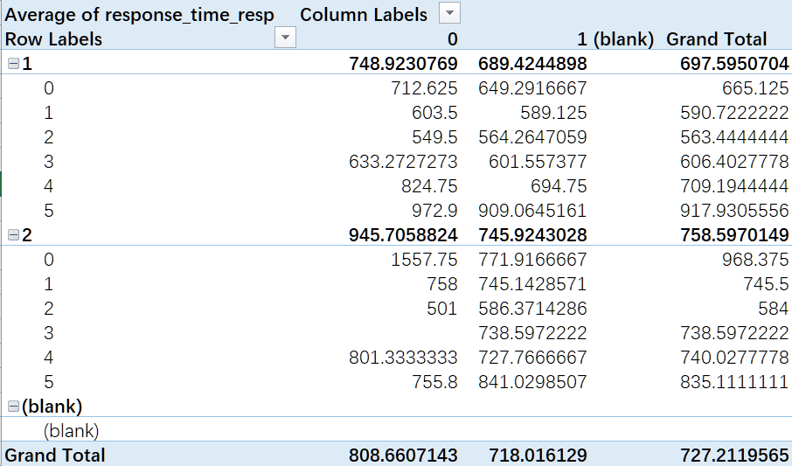

**Figure 5** The results of subject 1 in “.csv” file.

**Figure 7** It’s easier to categorize words and faces if the categories POSITIVE/YOUNG and NEGATIVE/OLD are combined (as compared to the reverse).

I collect two data from two different people, then put them together and use the pivot table to calculate. Then I subtract congruent condition (block 3) to incongruent condition (block 5) for the correct response trials.

For subject 1, the ageist bias is 909.06 – 601.56 = 307.5.

**Figure 6** The pivot table of 2 subjects.

For subject 2, the ageist bias is 841.03 – 738.60 = 102.43.

In this case, both subjects have ageist bias, and the subject 1 might have more bias than subject 2.